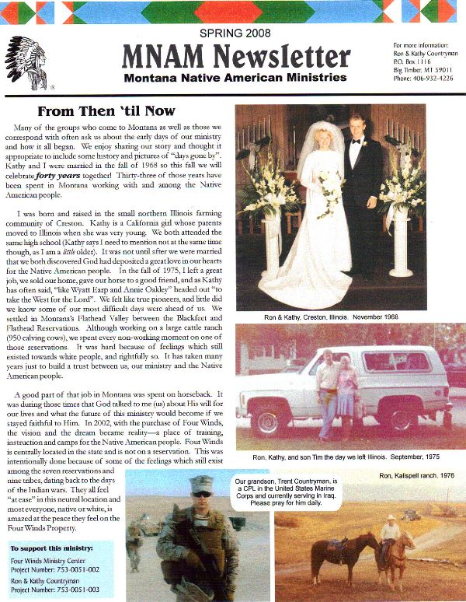

**Winter 2009**

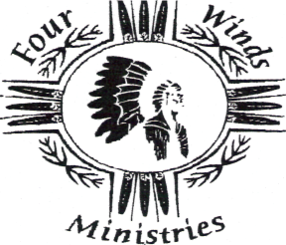

**OUR MISSION STATEMENT**

The mission of the Montana Native American Ministries and the Four Winds Ministry Center is to offer a higher purpose for living and equip lives by giving hope and an expected end through Jesus Christ. To assist the Native American people in achieving their complete identity in Christ, and be proud of their remarkable history and who they are.

**“We Give Thanks…”**

**Thanksgiving Distribution**

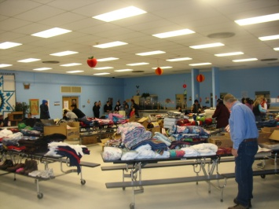 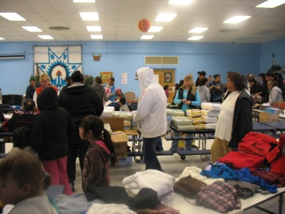 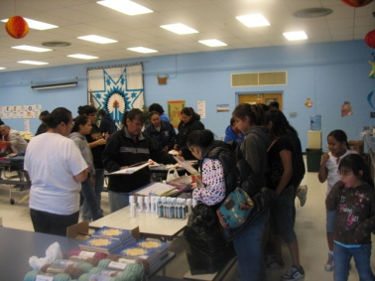 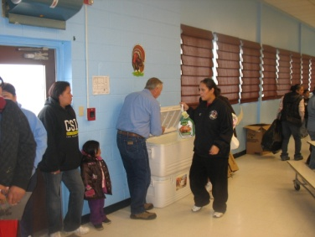

I open up the fridge at will

Turn up the heat when there’s a chill

***I’m*** fed, ***I’m*** warm, I know ***I’m*** safe

Yet from my mind cannot escape

The pleading in those innocent eyes

The never-ending wondering “why’s”

“We have no hope, no clothes, no food

Can you please help? Is there something you can do?”

They are in a prison without a key

Knowing this need, we can’t turn away

When dark brown eyes into mine gaze

Within my heart, a question will raise

What can we do for these poor babes?

How can they make it through the day?

To see, feel and know of their needs

Will humble you, break you, bring you to your knees

Winter’s here, it’s time to prepare

The season’s here in which we share

The hope and peace and love of God

But wait, there’s a need you may not know of:

Of cold, of hunger, of shame and despair

Of families alone ‘cause no one will “**GO THERE**”

We need your help to meet this task

Please talk to God is all we ask

To help these children who stand in need

We’ll do our best to clothe and feed

We send out thanks with all our hearts

For joining with us in some small part!

~Kathy Countryman~

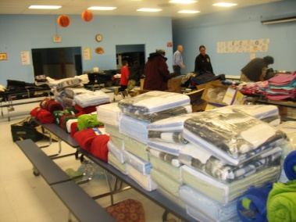 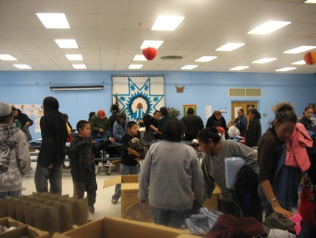

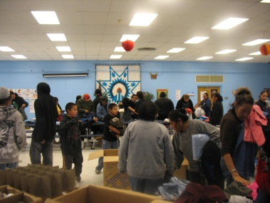 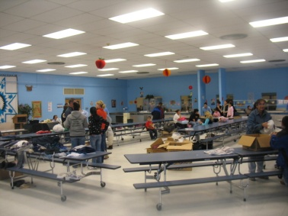

From the first picture (top left) to the last (bottom right) only **13 minutes** elapsed. “An estimated **3.5 million** children younger than 5 are at risk of hunger in the United States” (AG publication)

“No one is useless in this world who lightens the burdens of another” ~Charles Dickens~

**Winter Comes Early at Four Winds**

**October 16th Brings First Snow**

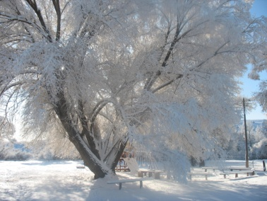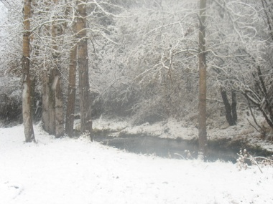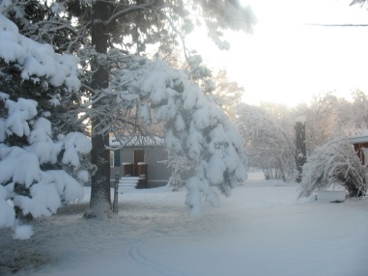

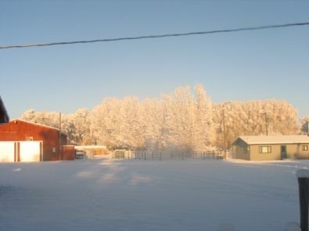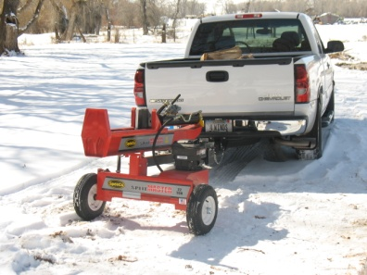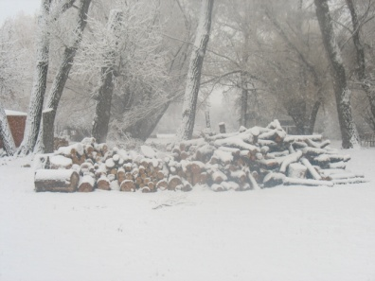

New Log Splitter Provided

The winter scenes above can take your breath away…and so can the utility bills. November through March find us facing power bills anywhere from $800-$1200 monthly. Would you or your group consider helping us properly heat and maintain the buildings at Four Winds?

**2009 Fall Retreat, Birmingham, AL**

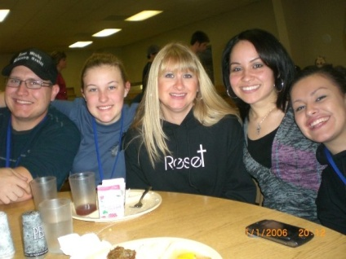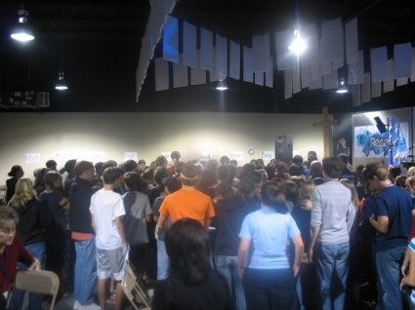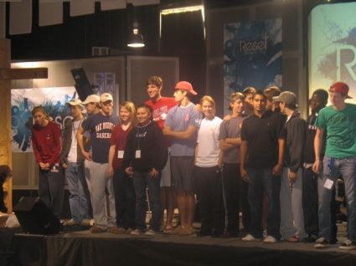

Justin, Kim and Shannlyn Spotted Elk (first picture, far right) were able to attend Asbury UMC’s 2009 Annual Fall Retreat. God miraculously provided the means for all three to attend this event! We will always cherish the love, friendship and encouragement Asbury poured into us! We love all y’all!

**Please check out our new website to learn more about our ministry: videos, pictures, calendar, etc.**

<http://www.fourwindsministrycenter.com>.

**FOUR WINDS MINISTRY CENTER:**

**KIM: 406-932-4224** [**kim_4winds@yahoo.com**](mailto:kim_4winds@yahoo.com)

**JUSTIN: 406-930-0497**

**MNAM: 406-932-4226**

**RON & KATHY COUNTRYMAN**

**PO BOX 1116**

**BIG TIMBER, MT 59011**

**CONTACT INFORMATION**